Your Yard Needs Mowing

Your grass is at or near public nuisance height (12 inches). Please make arrangements to keep it mowed on a regular basis throughout the growing season.

Thank You for Helping to Keep our City Safe, Healthy and Attractive.
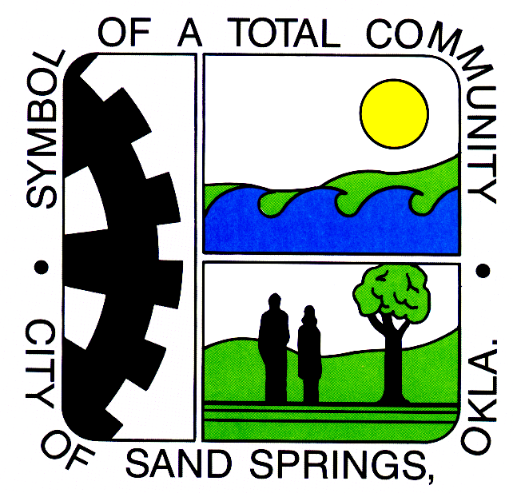
City of Sand Springs, Oklahoma
Neighborhood Services Department
110 E. Broadway
Sand Springs, OK 74063

(918) 246-2574

